**User Manual for Audit Management Web Application**

**Table of Contents**

1. Introduction
2. User Authentication
   * 2.1 Logging In
3. User Data Management
   * 4.1 Adding Users
   * 4.2 View Users
   * 4.3 Editing User Information
4. Source Reference
   * 5.1 Adding Source References
   * 5.2 Viewing Source References
   * 5.3 Editing Source References
5. Audit Planning Module
   * 3.1 Creating an Audit Plan
   * 3.2 Editing an Audit Plan
   * 3.3 Viewing Audit Plans
6. Reporting
   * 6.1 Generating Reports
   * 6.2 View Reports
7. Export Audit Report
   * 7.1 Select Reports.
   * 7.2 Export Reports.
8. Scheduling Audit Reports
   * 8.1 Creating a Schedule
   * 8.2 Viewing Scheduled Reports
9. Support and Contact Information

**1. Introduction**

Welcome to the Audit Management Web Application. This application is designed to streamline the audit process, facilitate collaboration, and enhance reporting efficiency. This manual provides a comprehensive guide to using the various modules of the application.

**2. User Authentication**

**2.1 Logging In**

**URL of the application:** (SIT url – need to connect with VPN)

**http://acnproject3.acnovate.local:8080/audit-manager/authentication/sign-in**

1. Open the web application.
2. Enter your username and password.
3. Click the "Login" button.
4. If the credentials are correct, you will be redirected to the dashboard.

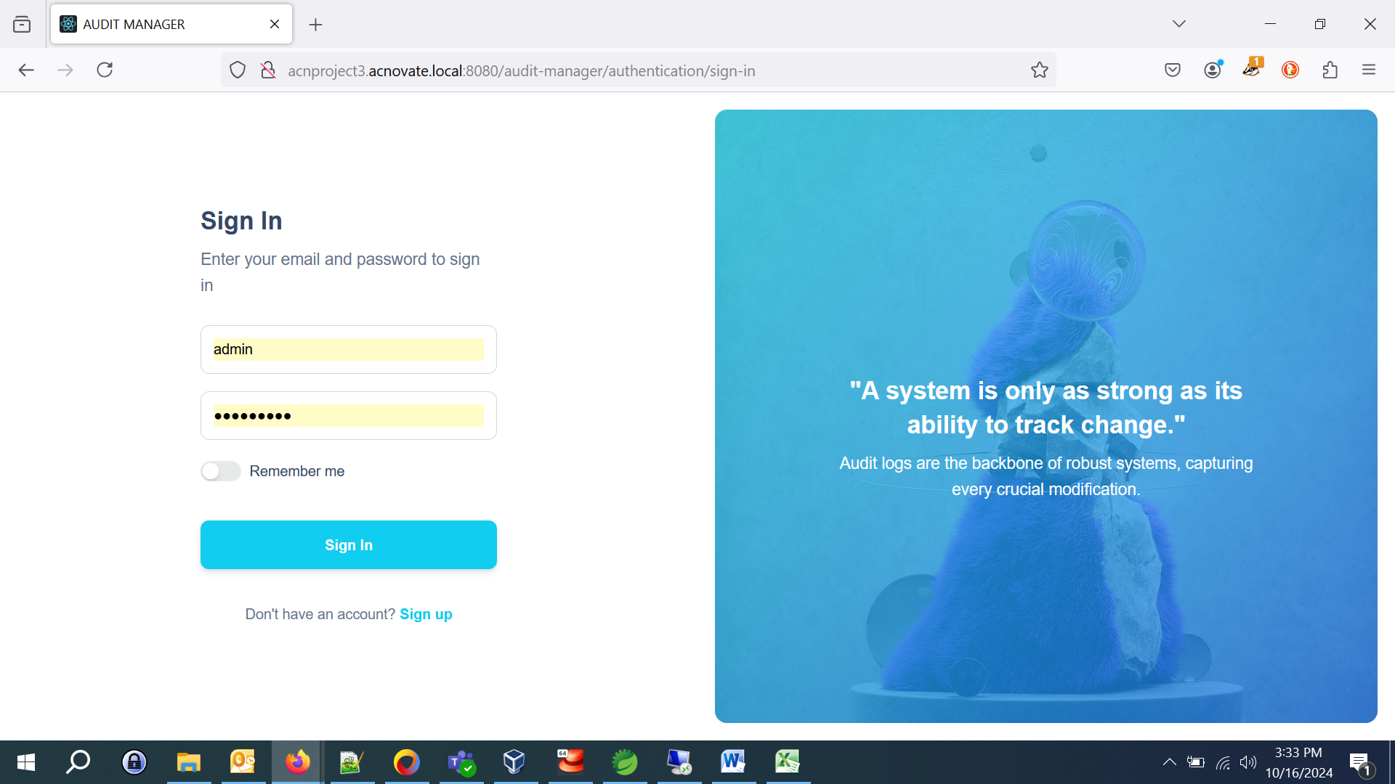

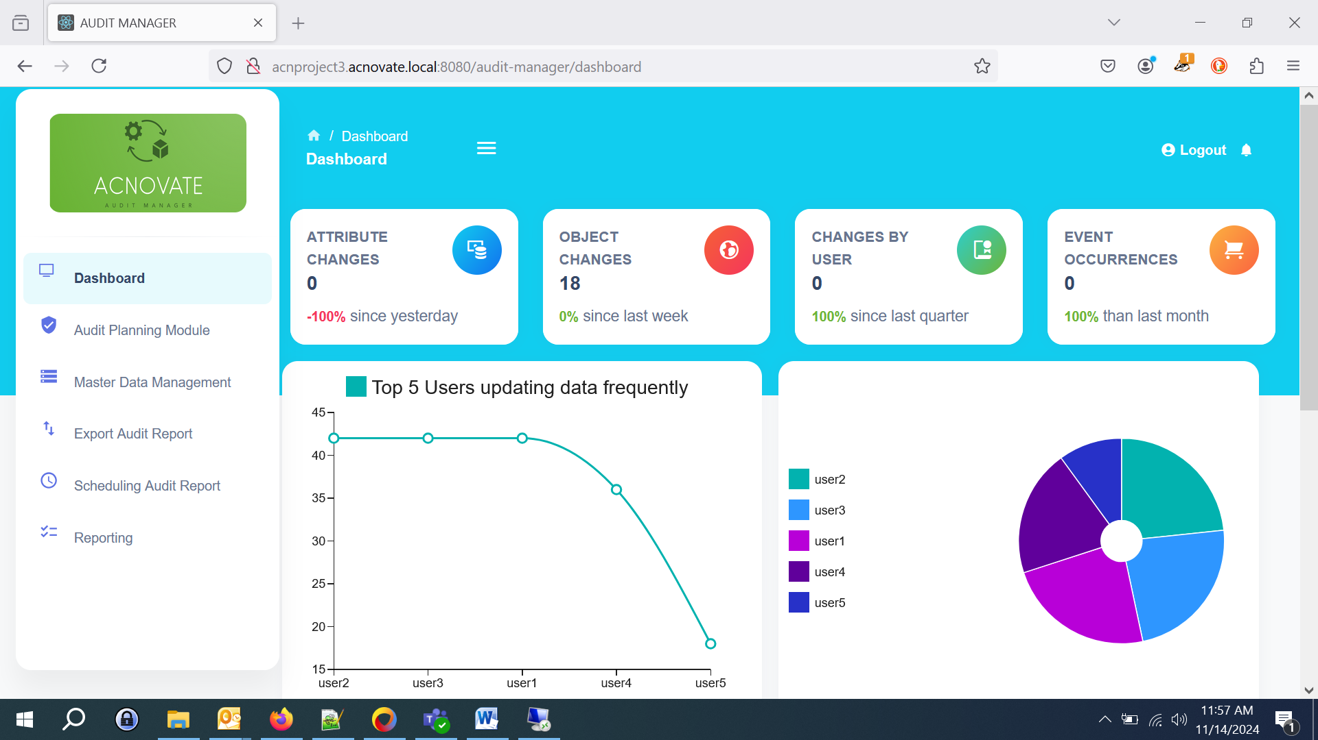

**3. User Data Management**

**3.1 Adding Users**

(Only administrators can create users here.)

1. Navigate to the "User Data Management" section.
2. Click "Create"
3. Enter the user's information (full name, email, role, user name) and click "Submit."
4. User will get the email with the default password which can be editable in edit user section.

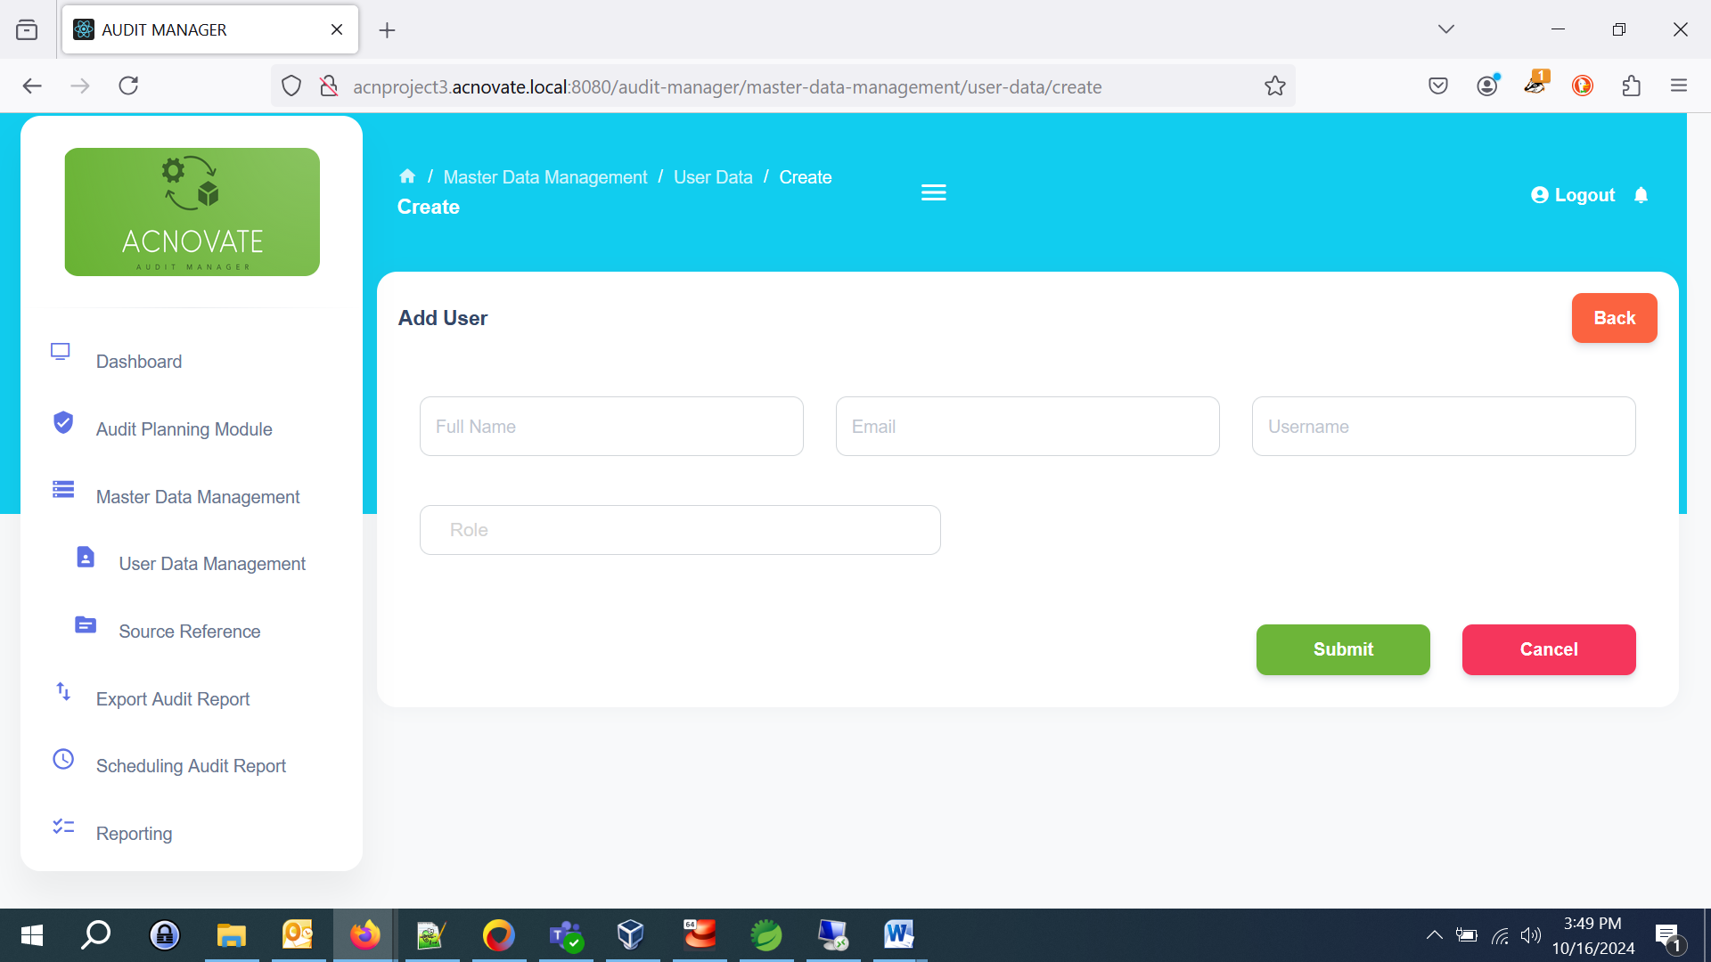

**3.2 View Users**

1. All users can be view under “User View” section.

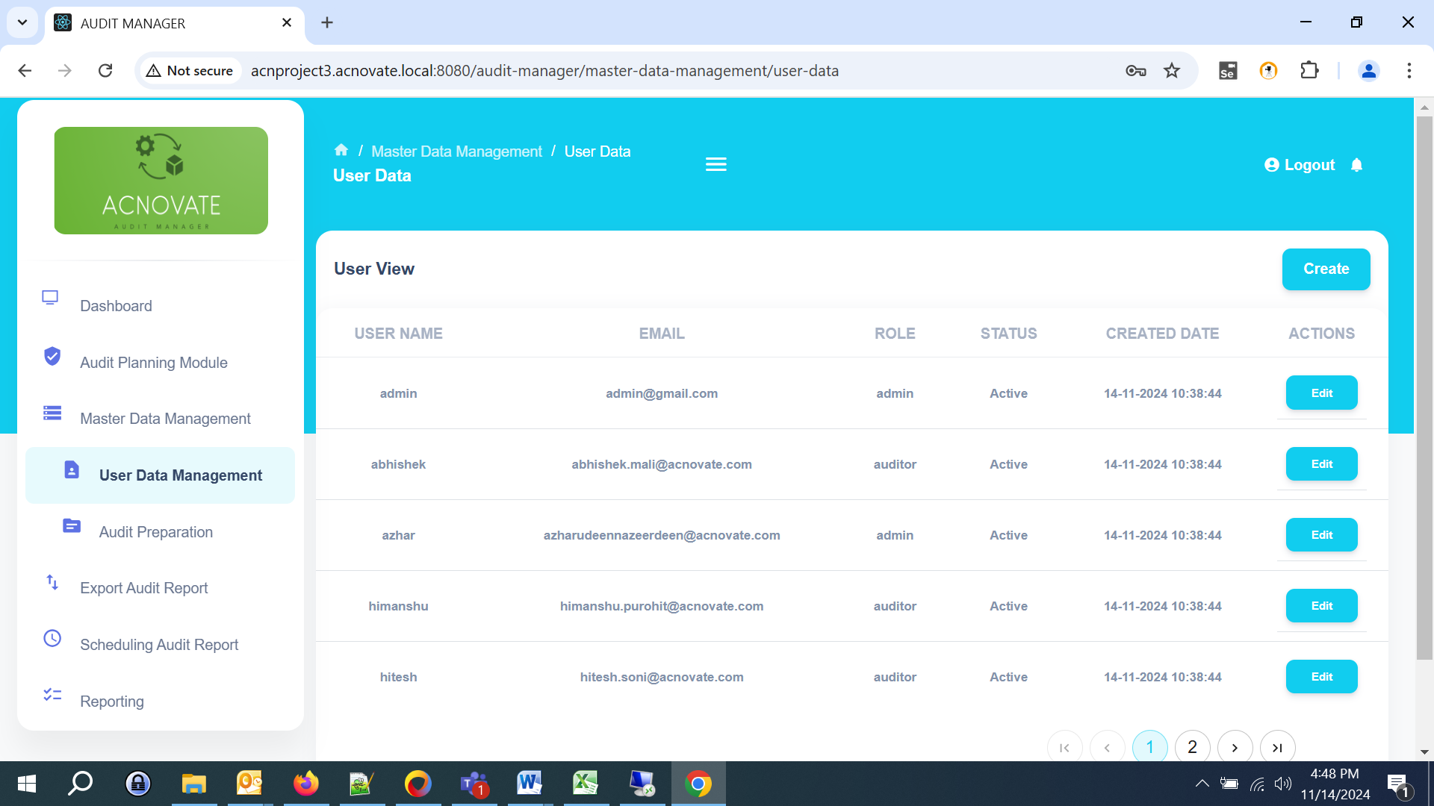

**3.3 Editing User Information**

1. In the "User View" section, click “Edit” button to update user details.

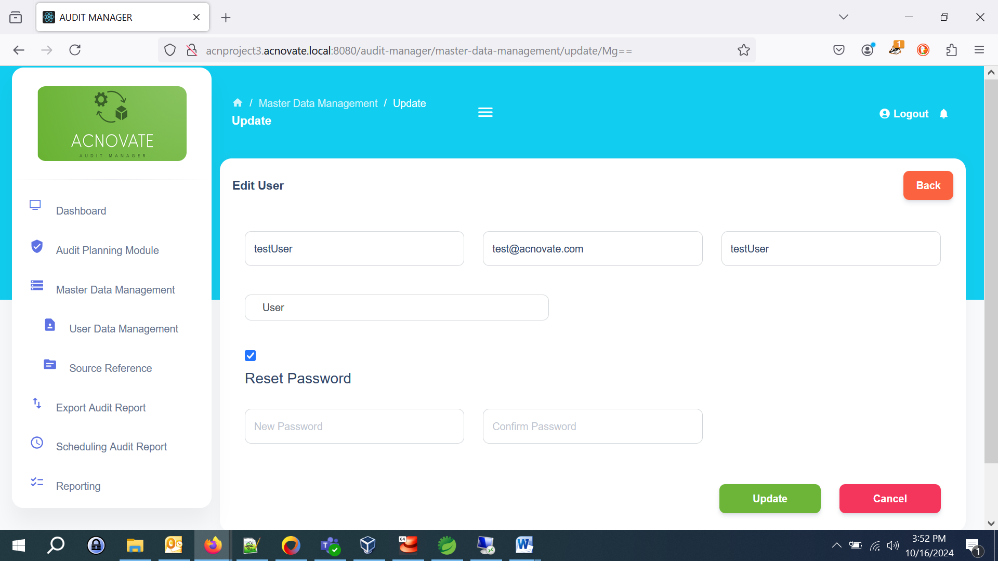

**4. Audit Preparation**

**4.1 Adding Audit Preparation**

1. Go to the "Audit Preparation" module.
2. Click "Create" button to add Audit Preparation.
3. Fill in the details (Audit Reference, Audit Reference Id) and click "Save."

Note: Here we're introducing "Audit Preparation" concept. This approach helps us identify and manage updates to individual entities, even when they're modified several times. The Audit Preparation allows us to uniquely distinguish each instance of an entity, making it possible to track and update specific records as needed.

Example

Let's say we have an entity in a table named Product with an ID of 123. The first time this entity is created, we establish:

Audit Reference: Product

Audit Reference Key: 123

This unique combination (Product, 123) allows us to track each update to this Product entity under a consistent reference.

Using this approach, we maintain a single reference point for the entity, regardless of how many updates it undergoes. This eliminates the risk of creating multiple redundant references for the same entity, enabling efficient tracking and management.

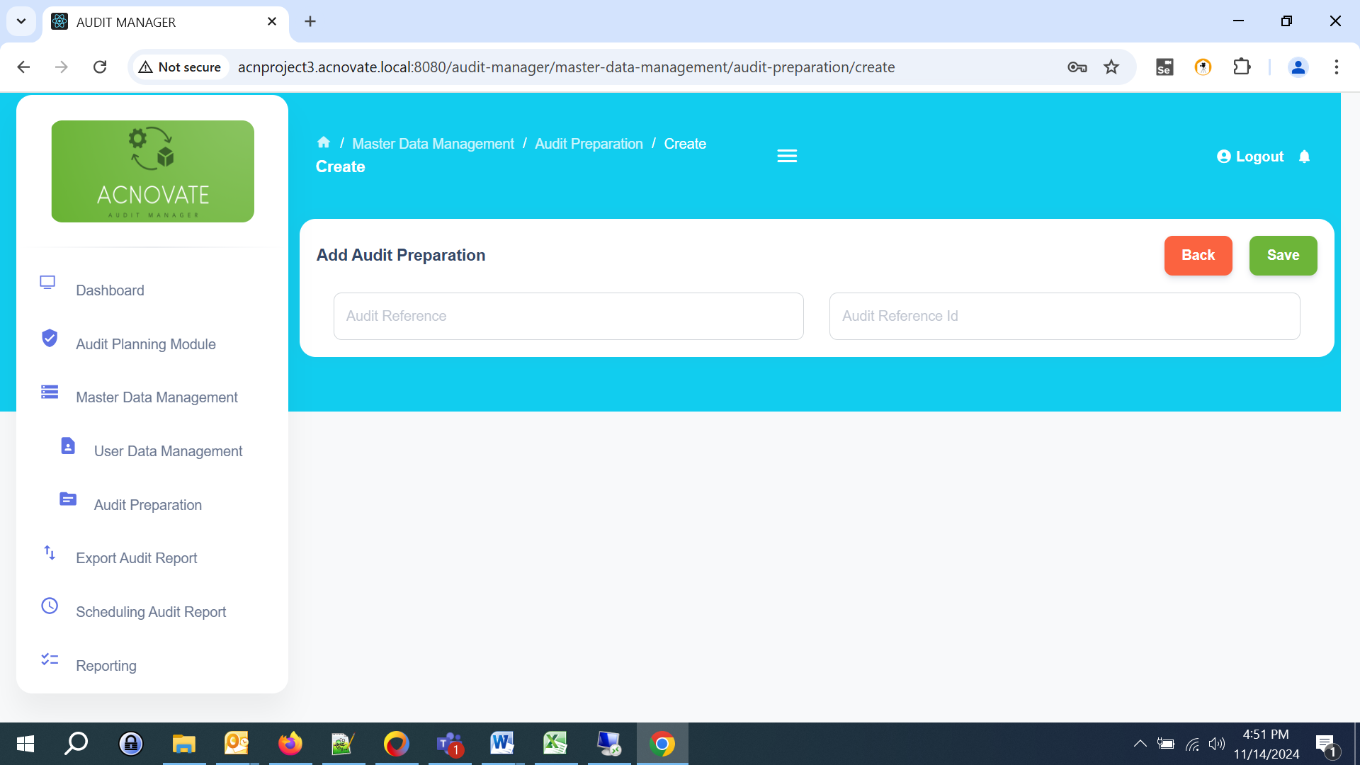

**4.2 Viewing Audit Preparation**

* Navigate to the "Audit Preparation" module to view all entries.

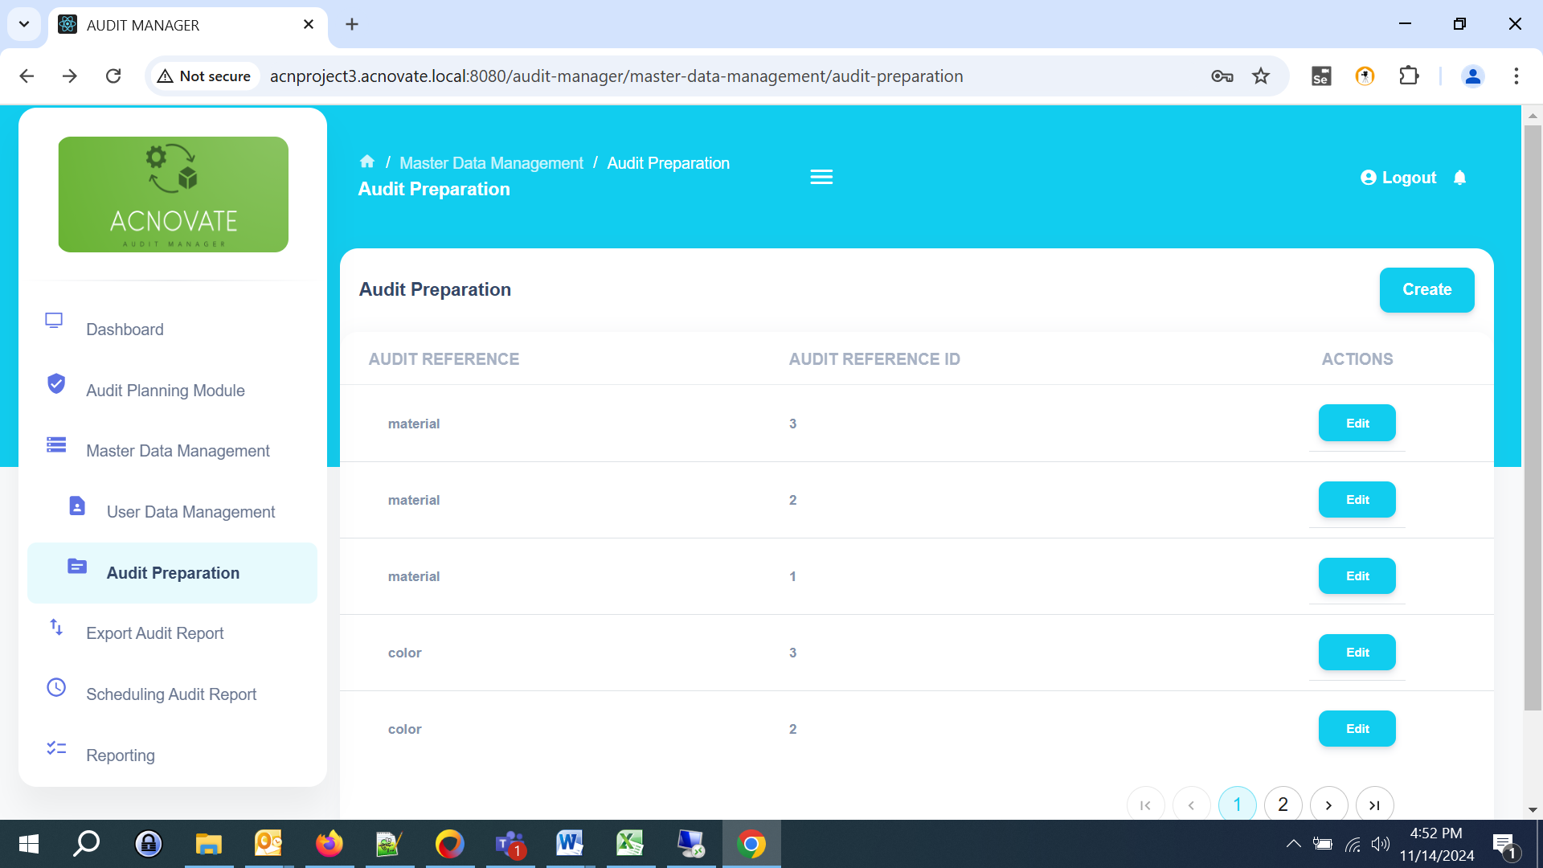

**4.3 Editing Audit Preparation**

1. In the "Audit Preparation" section, click “Edit” button to update details.

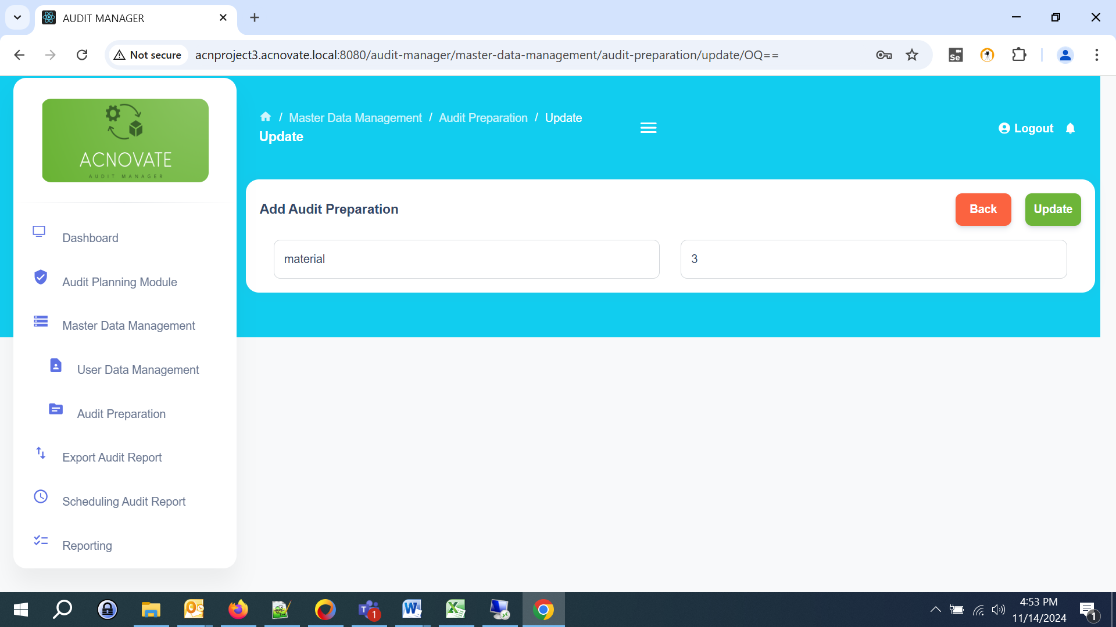

**5. Audit Planning Module**

**5.1 Creating an Audit Object**

1. Navigate to the “Audit Planning Module” section from the dashboard.
2. Click “Create” button to create a new audit object."
3. Fill in the required details.
4. Here the user can search the Audit Reference from a predefined list.
5. After selecting the audit reference, the user can fill the other required details of audit objects.
6. Click "Save" to create the object.

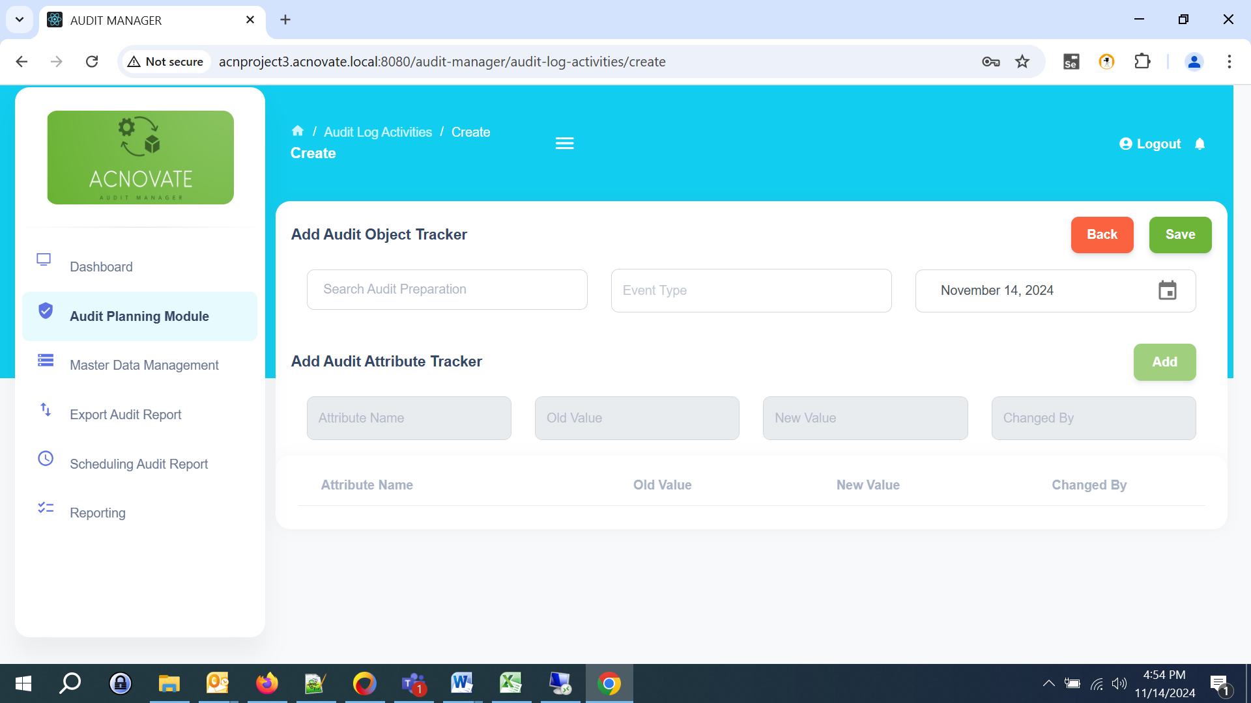

**5.2 Editing an Audit Object**

1. Go to the "Audit View" list.
2. Select the audit object you wish to edit.
3. Click “Update” button to edit the details.

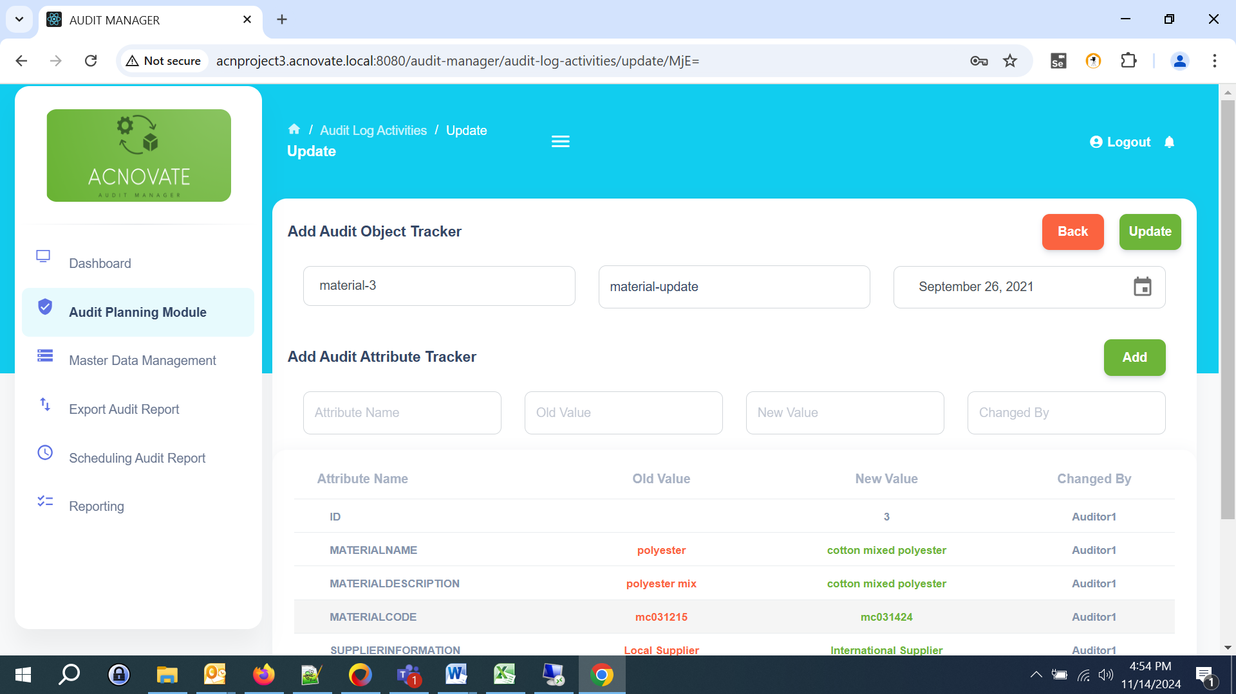

**5.3 Viewing Audit Objects**

* To view existing Audit Planning, go to the "Audit View" section, where you can see a list of all Audit Object with the attribute history and options to filter and search.

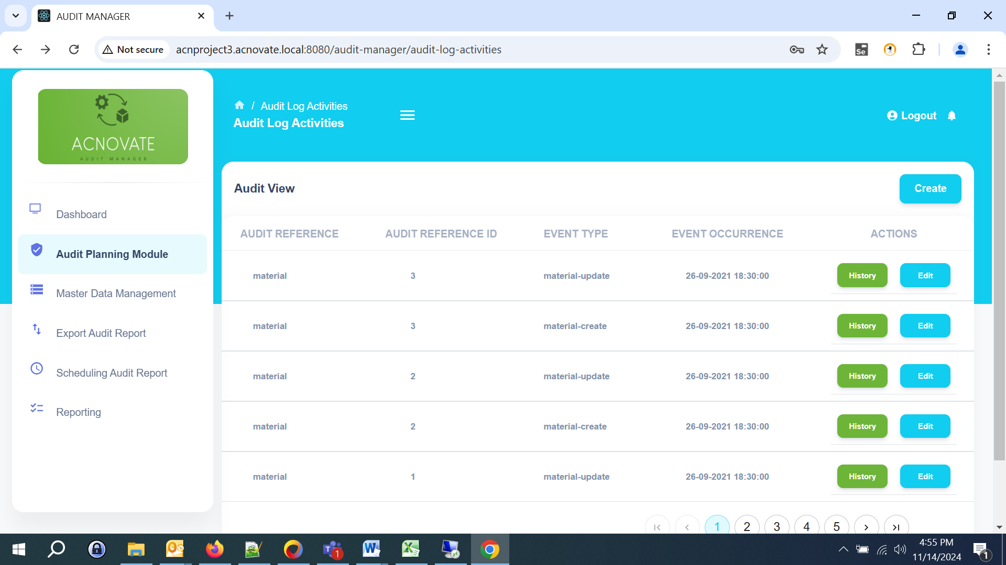

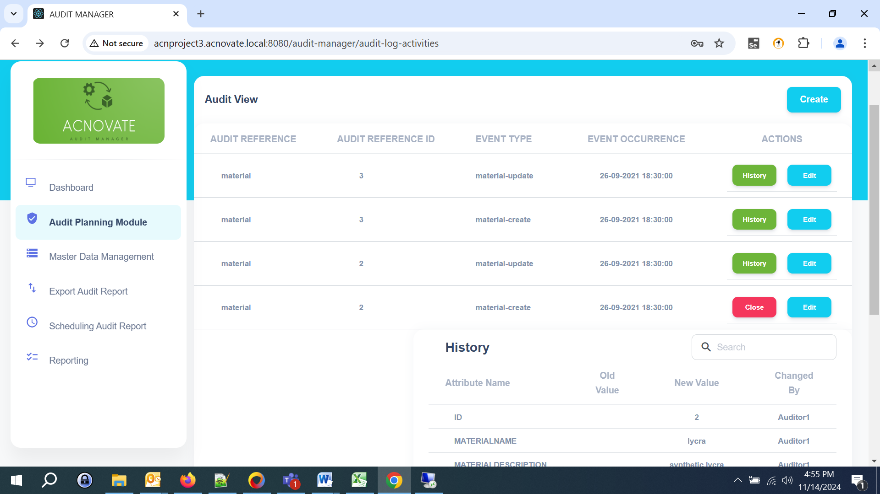

**6. Reporting**

**6.1 Generating Reports**

1. Navigate to the "Reporting" module.
2. Fill the required fields to generate (Report Name, Audit Reference, Start and End Date, Changed Users).
3. Click "Save."

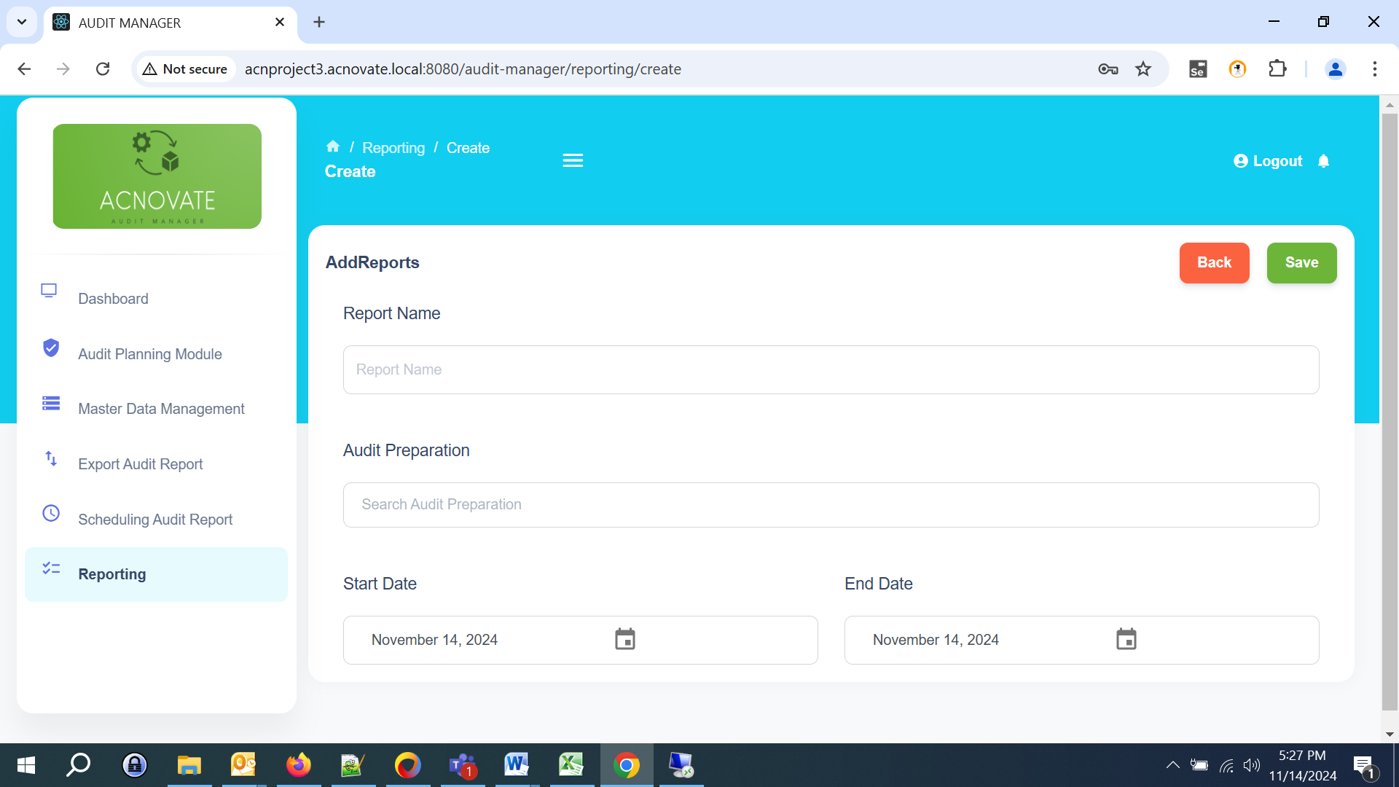

**6.2 View Reports**

* User can have “Report Overview” to see all the entries.

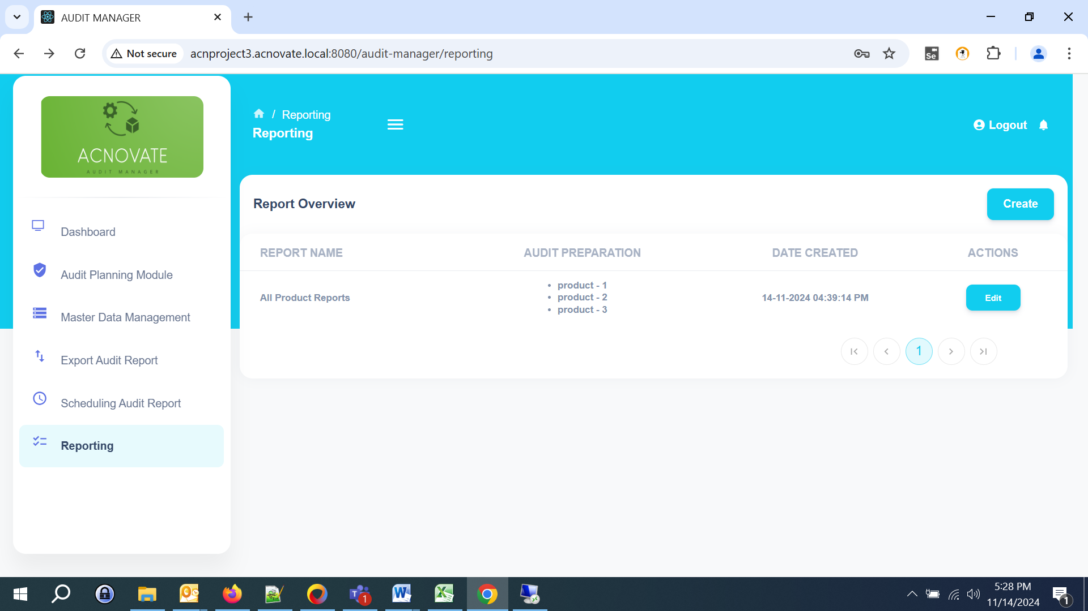

**7. Export Audit Report**

1. Navigate to the "Export Audit Report" module.
2. Select single or multiple lists, from which you wish to export audits.

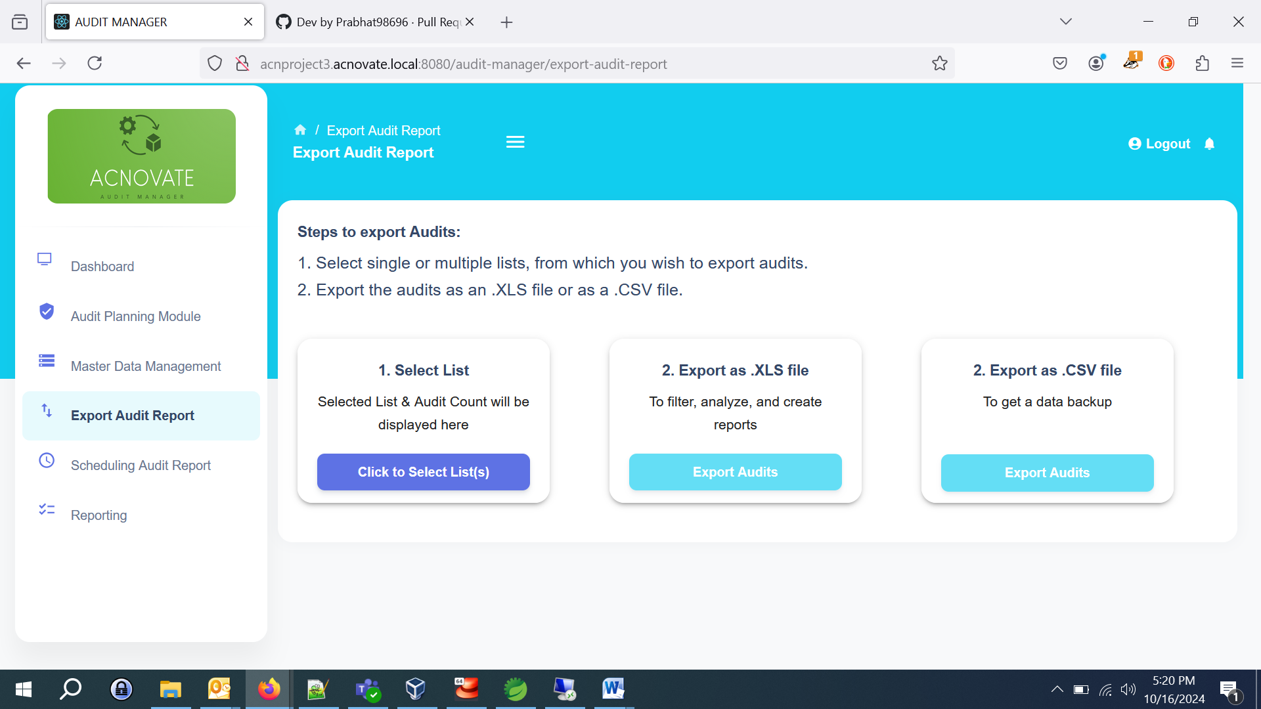

**8. Scheduling Audit Reports**

**8.1 Creating a Schedule**

1. Go to the "Scheduling Audit Reports" section.
2. Click "Create" to Schedule Audit Report
3. Fill in the necessary details (Report Name, Frequency, Recipients that can be multiple) and click "Save Schedule".
4. Recipients will get mail with attachment.

**8.2 Viewing Scheduled Reports**

* To view all scheduled reports, navigate to the "Scheduling Audit Report" section where you can see a list.

**9. Support and Contact Information**

For additional support, please contact our help desk:

* **Email:** infoauditmanagement@gmail.com
* **Mobile:** (+91) 8233299242

Thank you for using the Audit Management Web Application! We hope this manual helps you navigate the system effectively.